**PART A**

(Part A: TO BE REFERRED BY STUDENTS)

**Experiment No. 04**

**A.1 AIM:**

Design of static website with HTML5 and CSS tags.

**A.2 Pre requisite:**

Basic Knowledge of CSS and HTML tags.

**A.3 Outcome:**

After successful completion of this experiment students will be able to:

1. Design pages in HTML
2. Perform all formatting of text and images in HTML
3. Apply styling technique Using Inline CSS
4. Apply styling technique Using Internal CSS
5. Apply various styling techniques Using External CSS.

**A.4 Theory:**

**Its good practice to follow following html format: -**

<!DOCTYPE html>  
<html lang="en-us">  
<head>

<meta charset="utf-8">  
  <title> Title</title>  
</head>  
<body>  
🡪your code will go here…  
</body>  
</html>

**Video:-**

Video element <video>

* Video tag uses a src attribute or embedded <source>
* Common attributes
  + height, width
  + autoplay
  + loop
  + controls
* Text inside <video>..</video> is displayed if browser cannot support tag

**Audio: -**

* Audio tag uses a src attribute to link to audio file, typically .mp3 or .wav
* Common attributes
  + autoplay, controls, loop
  + buffered
  + muted
  + volume

**HTML Formatting: -**

* <b> - Bold text
* <strong> - Important text
* <i> - Italic text
* <em> - Emphasized text
* <mark> - Marked text
* <big> - Bigger text 🡪 not supported by html-5
* <small> - Smaller text
* <del> - ~~Deleted text~~
* <ins> - Inserted text
* <sub> - Subscript text T1
* <sup> - Superscript text T2

**Non Semantic Tag(HTML-4): -**

<div>

* The <div> tag defines a division or a section in an HTML document.
* The <div> tag is used as a container for HTML elements
* Any sort of content can be put inside the <div> tag!

<span>

* A <span> element which is used to color a part of a text
* The <span> tag is an inline container used to mark up a part of a text, or a part of a document.

<div> is a block-level element and <span> is an inline element

<div> and <span> are non-sematic tag

<div> and <sapn> Tells nothing about its content

**Few New Elements in HTML-5**

**<header>**

* The <header> element represents a container for introductory content or a set of navigational links.
* A <header> element typically contains:
  + one or more heading elements (<h1> - <h6>)
  + logo or icon
  + authorship information
* You can have several <header> elements in one HTML document.
* However, <header> cannot be placed within a <footer>, <address> or another <header> element.

**<nav>**

* The <nav> tag defines a set of navigation links.
* Notice that NOT all links of a document should be inside a <nav> element.
* The <nav> element is intended only for major block of navigation links.

**<section>**

* The <section> element defines a section in a document.
* According to W3C's HTML documentation: "A section is a thematic grouping of content, typically with a heading."

# **<article>**

* The <article> tag specifies independent, self-contained content.
* An article should make sense on its own and it should be possible to distribute it independently from the rest of the site.
* Potential sources for the <article> element:
  + Forum post
  + Blog post
  + News story

## <aside>

* The <aside> tag defines some content aside from the content it is placed in.
* The aside content should be indirectly related to the surrounding content.
* The <aside> content is often placed as a sidebar in a document.

**<figure > & <fgcaption>**

* Use a <figure> element to mark up a photo in a document
* <figcaption> element to define a caption for the photo:

**<footer>**

* The <footer> tag defines a footer for a document or section.
* A <footer> element typically contains:
  + authorship information
  + copyright information
  + contact information
  + sitemap
  + back to top links
  + related documents
* You can have several <footer> elements in one document.

**<main>**

* The <main> tag specifies the main content of a document.
* The content inside the <main> element should be unique to the document.
* There must not be more than one <main> element in a document. The <main> element must NOT be a descendant of an <article>, <aside>, <footer>, <header>, or <nav> element.

<mark> Text </mark> 🡪 Highlights the text in yellow

**<time>**

* The <time> tag defines a specific time (or datetime).

Example:-

<time>10:00</time> to <time>21:00</time>

<time datetime="2020-07-18 10:50">

**<details> and <summary>**

* The <details> tag specifies additional details that the user can open and close on demand.
* The <summary> tag defines a visible heading for the [<details>](https://www.w3schools.com/tags/tag_details.asp) element. The heading can be clicked to view/hide the details.
* The <details> tag is often used to create an interactive widget that the user can open and close. By default, the widget is closed. When open, it expands, and displays the content within.
* The <summary> element should be the first child element of the <details> element.

**Reference: - https://www.w3schools.com**

**Cascading Multiple Sheets:**

* You can use multiple sheets to define the style of your document
* Internal styles will override external styles, if they are duplicated

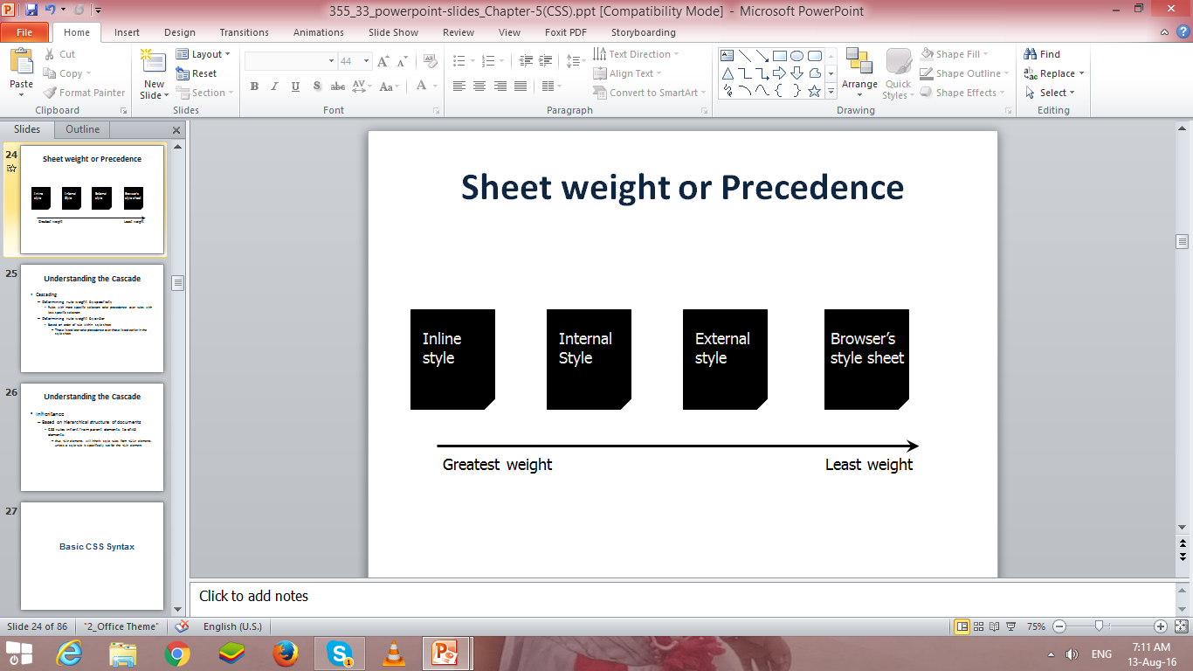

**Multiple Properties:-**

* You can specify multiple properties to a single selector. Properties must be separated by a semicolon.
* Example:-
  + P { text-align: left; color: red }`

**Basic CSS Syntax:**

To make properties more readable, put each on a separate line.

p { text-align: center;

color: navy;

font-family: arial

}

**Groping Selectors:-**

* Selectors can be grouped so that a common property can be specified
* Example:-

h1,h2,h3,h4,h5,h6

{ color: red }

**Descendants:-**

* Selectors can be descendants [combine]
* Example:-

P B { color: red }

* In this example, only those <B> elements within a <P> element would be yellow
  + <p><b> This would be yellow </b></p>
* <p> This would not be yellow </p>

#### Common Selectors

| **Example** | **Classification** | **Explanation** |
| --- | --- | --- |
| h1 | Type Selector | Selects an element by its type |
| .tagline | Class Selector | Selects an element by the class attribute value, which may be reused multiple times per page |
| #intro | ID Selector | Selects an element by the ID attribute value, which is unique and to only be used once per page |

**Class Selectors**

* *Class* selectors allow us to select an element based on the element’s class attribute value.
* Class selectors are a little more specific than type selectors, as they select a particular group of elements rather than all elements of one type.
* Class selectors allow us to apply the same styles to different elements at once by using the same class attribute value across multiple elements.
* Within CSS, classes are denoted by a leading period, ., followed by the class attribute value.
* Example: -
  + Here the class selector will select any element containing the class attribute value of awesome, including both division and paragraph elements.

###### CSS

|  |  |
| --- | --- |
| 1  2 | .awesome { ... } |

###### HTML

|  |  |
| --- | --- |
| 1  2  3 | <div class="awesome">...</div>  <p class="awesome">...</p> |

### ID Selectors

* ID selectors are even more precise than class selectors, as they target only one unique element at a time.
* Just as class selectors use an element’s class attribute value as the selector, ID selectors use an element’s id attribute value as a selector.
* Regardless of which type of element they appear on, id attribute values can only be used once per page. If used they should be reserved for significant elements.
* Within CSS, ID selectors are denoted by a leading hash sign, #, followed by the id attribute value.
* Example:-
  + Here the ID selector will only select the element containing the id attribute value of shayhowe.

###### CSS

|  |  |
| --- | --- |
| 1  2 | #shayhowe { ... } |

###### HTML

|  |  |
| --- | --- |
| 1  2 | <div id="shayhowe">...</div> |

**List of Background Properties:-**

* + background
  + [background-color](http://www.w3schools.com/css/tryit.asp?filename=trycss_background-color)
  + [background-image](http://www.w3schools.com/css/tryit.asp?filename=trycss_background-image)
  + [background-repeat](http://www.w3schools.com/css/tryit.asp?filename=trycss_background-repeat)
  + [background-attachment](http://www.w3schools.com/css/tryit.asp?filename=trycss_background-attachment)
  + [background-position](http://www.w3schools.com/css/tryit.asp?filename=trycss_background-position)

**Commonly used Text Properties:-**

* + color
  + direction
  + text-align
  + text-decoration
  + text-indent

**Some Font Properties:-**

* font-style
* font-variant
* font-weight
* font-size/line-height
* font-family

**Border Properties:-**

* You can specify the width, style, color, thickness and on which sides the border appears
* Border-style🡪 dotted, dashed, solid, double etc/
* Border-width🡪 thin, medium,thick
* Border-top-width
* Border-top

**Margin Properties:-**

* + margin
  + margin-top
  + margin-right
  + margin-bottom
  + margin-left

**Tasks**

1. **Design simple HTML page to display, your Name, SAP ID, Roll No, Program, Branch and Year. It should include some audio video as well.**

Apply Styling for font, colour properties using following CSS.

1. Apply styling technique Using Inline CSS
2. Apply styling technique Using Internal CSS
3. Apply various styling techniques Using External CSS.
4. Importing Styles.
5. Apply styling to HTML code implemented in EXPT-3 (your CV) using external CSS…

Apply styling to following.

* Apply Styling for Following to Normal Text…
  + Background Properties.
  + Text Properties.
  + Font Properties.
  + Margin Properties.
  + Grouping of Selector.
  + Descendants.
* Apply Styling for following
  + Lists…
    - list-style-type
    - Styling Lists with Colors
  + Table Property:
    - The table should be styled using at least four properties
    - The table headings should have a border, background color, and at least one other property.
    - Style the table so that the text in the first column is left-aligned and the text in the other two columns is centered
    - The table elements < td > should be styled using at least four properties

1. **Challenge: -** Apply styling to HTML code implemented in EXPT-3(your CV) using external CSS… & display it in following form with attractive look…

|  |  |  |
| --- | --- | --- |
| <Header>  Logo  Program  Your Name  Objective | | |
| Nav  Version-1 of CV, Version-2 of CV, Vesion-3 of CV | | |
| Aside  Education Table | Main  Technical Skills Table(Expt-1) | Aside  Key Projects |
| <footer>  Technical Presentation  Technical Work experience | | |

1. The CSS code (of question 2 or 3) should be validated at w3c validator

<http://www.css-validator.org>

**PART B**

(PART B: TO BE COMPLETED BY STUDENTS)

(Students must submit the soft copy as per following segments within two hours of the practical. The soft copy must be uploaded on the Blackboard or emailed to the concerned lab in charge faculties at the end of the practical in case the there is no Black board access available)

|  |  |
| --- | --- |
| Roll No. : | Name: |
| Class : | Batch : |
| Date of Experiment : | Date/Time of Submission : |
| Grade : |  |

**B.1 Code:**

*(Paste your Code here)*

**B.2 Output**

*(Take screen shots of the output at run time and paste it here)*

**B.3 Conclusion:**

*(Students must write the conclusion as per the attainment of individual outcome listed above)*

**B.3 Observations and Learning:**

*(Students must write their observations and learnings as per the attainment of individual outcome listed above)*

**B.4 Question of Curiosity**

*(To be answered by student based on the practical performed and learning/observations)*

1. What is CSS? What are its type??
2. Validator output??

Input code to validator: -

* Print Screen

Output of validator: -

* Print Screen